Lab Guide for Cascading Style Sheet (CSS)

**Contents**

COPYRIGHT NOTICE ii

Document Revision Summary i

Background 1

CSS Assignments 1

Assignment 1: Understanding CSS 1

Assignment 2: CSS syntax 3

Assignment 3: Some more selectors 6

Assignment 4: External Style sheet, <DIV> and <SPAN> 9

Assignment 5: Using text, font, box and position properties 11

Assignment 6: Applying styles to Tables and Form Elements 15

**Background**

This document contains the assignments to be completed as part of the hands on for the subject HJSX (Course code: HJSX). These tutorials assume a working knowledge of HTML.



**Note:** All assignments in this document must be completed in the sequence in order to complete the course.

**CSS Assignments**

All the assignments in this section must be completed on Day 2 of your HJSX course.

## Assignment 1: Understanding CSS

**Objective:** To understand the usage of CSS and provide cascading style for your HTML documents.

**Background:** You have learned how to create HTML documents. Style Sheets is a breakthrough in Web design because it allows developers to control the style and layout of multiple Web pages all at once.



**Note:** CSS1 Accepted by the W3C Consortium in 1996.

In 1998, CSS2 was introduced to add more power to CSS.

However, no browsers support all of the CSS2 features; although, many support parts of it.

Internet Explorer 6, Netscape 6, and Opera 6 have almost full support of CSS.

#### Estimated time: 10 minutes

**Step 1:** Type the following code and save it as css1.html.

<html>

<body>

<!-- Comment: Using Inline Style -->

<h2 style=”color:red”> This is my first HTML page with CSS</h2>

</body>

</html>

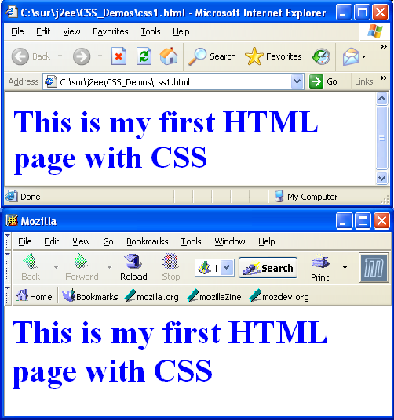

**Step 2:** In the above example replace the <h2> tag with the following code and save the file as css2.html

<h2 style="color:blue; font-size:10pt;"> This is my first HTML page with CSS</h2>

**Step 3**: Save the file as css3.html and change the color of the font to green and size of the font to 50 pt;

**Step 4**: Using style Tag, save the file as css4.html

<html><head>

<!-- Comment: <style> tag is used to define styles -->

<style>

<!-- Comment: Style defined for <h2> tag -->

h2{

}

color:red; font-size:30pt;

</style></head>

<body>

<h2> This is my first HTML page with CSS</h2>

</body>

</html>

#### Summary of this exercise:

You have just learnt

* Using inline style sheet.

#### Deliverables of the exercise:

* 1. css1.html
  2. css2.html
  3. css3.html
  4. css4.html

## Assignment 2: CSS syntax

**Objective:** To understand the CSS syntax and different kind of selectors.



**Note:** CSS syntax has two components, the selector and the style declaration. The *selector* specifies what the style rule is acting upon. A selector can be one of two things. It can be an HTML element name or it can be an attribute reference.

#### Estimated time: 10 minutes

**Step 1:** Type the following code and save it as “csselement.html”.

<html><head>

<style> h1{

color: red; font-size:30pt;

}

</style></head>

<body>

<h1> First H1 Tag</h1>

<h1> Second H1 Tag</h1>

</body>

</html>

**Step 2:** In the above code add <h2> tag and <h3> tag. Provide necessary style using element selector.



**Note:** HTML has an attribute called the class attribute. It is specifically for use with style sheets. Classes allow you to assign style rules only to selected elements that have the correct class attribute value in their tag.

**Step 3:** Type the following code and save the file as “class1.html”

<html><head>

<style>

h1{

color:red; font-size:30pt;

}

<!-- Comment: Style defined for h1 tag with classname ‘c’ --> h1.c

{

color:blue;

}

</style></head>

<body>

<!-- Comment: Style defined for h1 tag -->

<h1> First H1 Tag</h1>

<!-- Comment: Takes the Style defined for h1 tag with class name ‘c’

-->

<h1 class="c"> Second H1 Tag</h1>

</body></html>

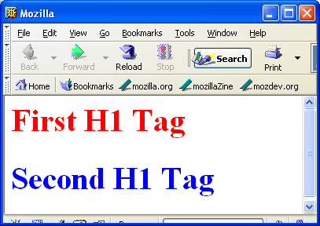

**Step 4:** In the above example add the following line and save it as “class2.html”. Check the output.

<h2 class="c"> new h2 Tag with class</h2>

**Step 5**: Type the following code and save the file as “class3.html”.

<html><head>

<style>

h1{

}

color:red;

font-size:30pt;

<!-- Comment: A generic style created with class name ‘c’ -->

.c

{

color:blue;

}

</style></head>

<body>

<h1> First H1 Tag</h1>

<h1 class="c"> Second H1 Tag</h1>

<h2 class="c"> Second H1 Tag</h2>

</body>

</html>

**Step 6:** Open css1.html in the browser (supplied with lab guide, check the folder HTML_CSS_JS_CODE_FOR_DEBUG). It is not displaying the output in red color. Debug the code and correct it.

#### Summary of this exercise:

You have just learnt

CSS syntax. Element selectors. Class selectors

#### Deliverables of the excercise:

1. csselement.html
2. class1.html
3. class2.html
4. class3.html

## Assignment 3: Some more selectors.

**Objective:** To understand different kind of selectors like Inheritance, Contextual Selectors**,** Grouping and pseudo selectors.



**Note:** Style properties are inherited from the parent element to the child

element.

#### Estimated time: 15 minutes

**Step 1:** Type the following code and save it as “cssinher.html”.

<html><head>

<style>

<!-- Comment: An example for Inheritance selector -->

body{

color: red;

}

h1

{

font-size:10pt;

}

</style></head>

<body>

<h1> Heading</h1> Some text

</body>

</html>

**Step 2:** Type the following code and save the file as “csscon.html”

<html><head>

<style>

<!-- Comment: An example for Contextual selector -->

p font{

color:red;

}

</style></head>

<body>

<p> Para <font> Inside font</font></p>

<font>Outside Para</font>

</body>

</html>



**Note:** The above style rule enforce that the text inside the <font> tag which is inside <p> tag will display in red color.

**Step 3:** Type the following code and save the file as “cssgroup.html”.

<html><head>

<style>

<!-- Comment: An example for Grouping selectors -->

p,font,h1{

color:red;

}

h1

{

font-size: 10pt;

}

</style></head>

<body>

<h1> Hello H1</h1>

<font> Hello Font</font>

<p> Hello P</p>

</body>

</html>

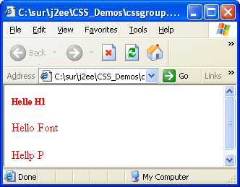



**Note:** The above style rule enforce that all the group element would display in same style.

**Step 4:** modify the above program and use class selectors instead of group selector and save as “cssclassnew.html”.



**Note:** Pseudo-classes are special "classes" that are automatically recognized by CSS-supporting browsers. Pseudo-classes can be assigned to the A element to display links, visited links and active links differently. The pseudo classes are

A:link -- link

A:active -- active link

A:visited -- visited link

A:hover -- Mouse Over

**Step 5:** Type the following code and save it as “csspsedo.html”.

<html>

<head>

<style>

<!-- Comment: An example for Pseudo selectors -->

a:link

{

color:blue;

}

a:visited

{

color:red;

}

</style>

</head>

<body>

<h2> Go to sparsh <h2><a hre[f="http://spars](http://sparsh/)h">Sparsh</a>

</body>

</html>

**Step 6:** In the above program include the following code inside the <style> tag.

a:hover

{

color:green;

}

**Step 7:** Open the page in browser and move mouse over the link and verify the output.

**Step 8:** In “psedo.html” add style for a:active pseudo class.

**Step 9:** Open css2.html in the browser (supplied with lab guide, check the folder HTML_CSS_JS_CODE_FOR_DEBUG). It is displaying the CSS code on the browser. Debug the code and correct it.

**Step 10:** Open css3.html in the browser (supplied with lab guide, check the folder HTML_CSS_JS_CODE_FOR_DEBUG). It is NOT displaying the text in 100 pt size. Debug the code and correct it.

#### Summary of this exercise:

You have just learnt

Inheritance selector. Contextual selector. pseudo selector.

Group selector.

#### Deliverables of the excercise:

1. cssinher.html
2. csscon.html
3. cssgroup.html
4. csspsedo.html

## Assignment 4: External Style sheet, <DIV> and <SPAN>

**Objective:** To understand the advantage of External style sheet and usage of <DIV> and

<SPAN> tag.



**Note:** An external style sheet is ideal when the style is applied to many pages. The external style sheet file extension should be “.css”.

#### Estimated time: 10 minutes

**Step 1:** Type the following code and save it as “ext.css”.

/* Comments: do not use <style> tag here */ h1

{

color:red;

}

h2

{

color:blue;

}

**Step 2:** Type the following code and save is as “extcss.html”. ( css file and html files should be inside the same folder).

<html><head>

<!-- Comment: The document refers to a separate external file ‘ext.css’ -->

<link rel="stylesheet" type="text/css" href="ext.css">

</head>

<body>

<h1> style from external css</h1>

<h2> style from external css</h2>

</body>

</html>



**Note:** The <link> element provides a way to define the relationship between linked objects. The <link> element allows a style sheet for a document to be referenced from a separate file.

**Note:** DIV was introduce as a generic block level element who's original purpose was to serve as a container(**block**) for the logical 'parts' or divisions of a document. The Span tag is a generic inline container element. If you want to group text without using a block element, use the <span> element.

**Step 3:** Type the following code and save it as “cssdiv.html”.

<html>

<head>

<style>

<!-- Comment: A style defined for Div tag --> div{

color:blue;

}

</style>

</head>

<body>

<div>

<h1>Division heading </h1>

<p>many paragraphs and block elements</p>

<p>Notice that color is blue</p>

<div>

</body>

</html>

**Step 4:** Modify the above program, include a <font> tag with some text inside the <div> tag. Save the file as “cssdiv1.html”.

**Step 5:** Type the following code and save the file as “cssspan.html”.

<html>

<head>

<style>

<!-- Comment: A style defined for span tag with class name as ‘imp’ --

>

span.imp

{

color:blue;

}

</style>

</head>

<body>

<p> In this sentence <span class="imp">Some of the text is important</span></p>

</body>

</html>

#### Summary of this exercise:

You have just learnt

External style sheet. Usage of <div> Usage of <span>

#### Deliverables of the excercise:

1. ext.css
2. extcss.html
3. cssdiv.html
4. csspspan.html

## Assignment 5: Using text, font, box and position properties

**Objective:** To understand the usage of defining font in text and appearance of the text. Defining box properties and

#### Estimated time: 15 minutes

**Step 1:** Type the following code and save it as “cssfont1.html”.

<html>

<head>

<style>

<!-- Comment: Defining style for tag h2 considering few font related properties -->

h2

{

font-style:italic; font-size:28pt; color:cyan;

}

</style>

</head>

<body>

<h2> Using Font Style</h2>

</body>

</html>

**Step 2:** Modify the above code and provide the font family as “Courier New”. Hint: use font-family property.

**Step 3:** Type the following code and save it as “csstext.html”.

<html>

<head>

<style> h2

{

letter-spacing:4pt; font-size:40pt; color:blue;

text-align:center;

}

</style>

</head>

<body>

<h2>Asreet Bank</h2>

</body>

</html>



**Step 4:** Modify the above program and display the text with underline. Hint: Use text-decoration property.

**Step 5:** Type the following code and save it as “cssborder.html”.

<html>

<head>

<style>

<!-- Comment: Defining style for tag h2 considering few border related properties -->

h2

{

text-align:center; color:blue;

border-width:thick; border-color:green; Border-style:solid;

}

</style>

</head>

<body>

<h2>Asreet<sup>&reg;</sup> Bank</h2>

</body>

</html>



**Note:** The **border** property is shorthand for setting the border-width, border- style, and border-color of an element's border.

**Step 6:** Modify the above program with the following code and save it as “cssborder1.html”.

<style> h2

{

text-align : center; color : blue;

border : thick dotted red;

}

</style>

**Step 7:** Type the following code and save the file as “csspos.html”.

<html>

<head>

<style> h2

{

letter-spacing:4pt; font-size:40pt; color:blue;

text-align:center; position: absolute; top:0px;

}

h3

{

letter-spacing:4pt; font-size:40pt; color:blue;

text-align:center;

position: absolute; top:20px; left:20px;

}

</style>

</head>

<body>

<h2>Asreet Bank</h2>

<h3>Asreet Bank</h3>

</body>

</html>

**Step 8:** Modify the above code, display a border around the text and save the file as “cssposborder.html”.

**Step 9:** Type the following code and save it as “cssabove.html”.

<html>

<head>

<style> h2

{

position:absolute; Z-index:1; color:red;

}

<!-- Comment: Defining style for img tag --> img

{

position:relative; top:-50px;

}

</style>

</head>

<body>

<h2>Asreet Bank</h2>

<img src="gec.jpg" width="200" height="150">

</body>

</html>

**Step 10:** Modify the above program and set the Z-index value as “-1”.

**Step 11:** Open css4.html in the browser (supplied with lab guide, check the folder HTML_CSS_JS_CODE_FOR_DEBUG). It is NOT displaying the border. Debug the code and correct it.

#### Summary of this exercise:

You have just learnt

Text properties. Font properties. Border properties. Position properties.

#### Deliverables of the exercise:

1. cssfont1.html
2. csstext.html
3. cssborder.html
4. cssborder1.html
5. csspos.html
6. cssabove.html

## Assignment 6: Applying styles to Tables and Form Elements

**Objective:** To understand the usage of CSS with tables and form elements.



**Note:** It’s possible to change the default look of a table and form elements by styling their html tags.

#### Estimated time: 10 minutes

**Step 1:** Create the following html file and save it as “csstab1.html”.

#### Hint:

#### Create separate class styles for the following:

#### Table heading

#### Even numbered rows

#### Odd numbered rows

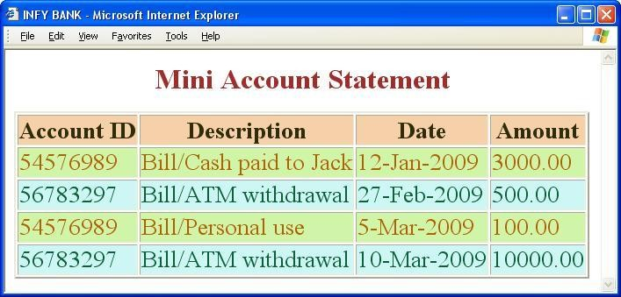

**Step 2:** Modify the above code by including the above created style classes in a separate external file cssexternal.css.

**Step 3:** Type the following code and save the file as “cssform1.html”.

<html>

<head>

<style> input{

form{

color:blue;

letter-spacing:3pt; font-size:14pt; }

border: thick solid blue; }

</style>

</head>

<body>

<form>

Name <input type="text" value="style"><br>

<input type="submit">

</form>

</body>

</html>

**Step 4:** create the following html file and save it as “cssform2.html”.



#### Summary of this exercise:

You have just learnt

Applying styles to <table>, <tr> and <td> tag. Applying styles to <form>, <input> and <select> tag. Applying external styles.

#### Deliverables of the exercise:

1. csstab1.html
2. cssexternal.css
3. cssform1.html
4. cssform2.html